**Practical no.-** 2

**Title:** Write a program to design a formusing the components List and Choice

**Roll No.:15** **Batch-** A **Date of Performance:** 31/07/2023

**Code-**

import java.awt.*;

public class SubOP extends Frame

{

public SubOP(String s)

{

super(s);

setVisible(true);

setSize(400,600);

Label lb=new Label("Select Subjects You Like");

lb.setBounds(50, 250, 150, 50);

add(lb);

List lt1=new List(4,true);

lt1.add("Maths");

lt1.add("Physics");

lt1.add("Chemistry");

lt1.add("C++");

lt1.add("Java");

add(lt1);

}

public static void main(String[] args) {

new SubOP("Subject Frame");

}

}

**Output-**

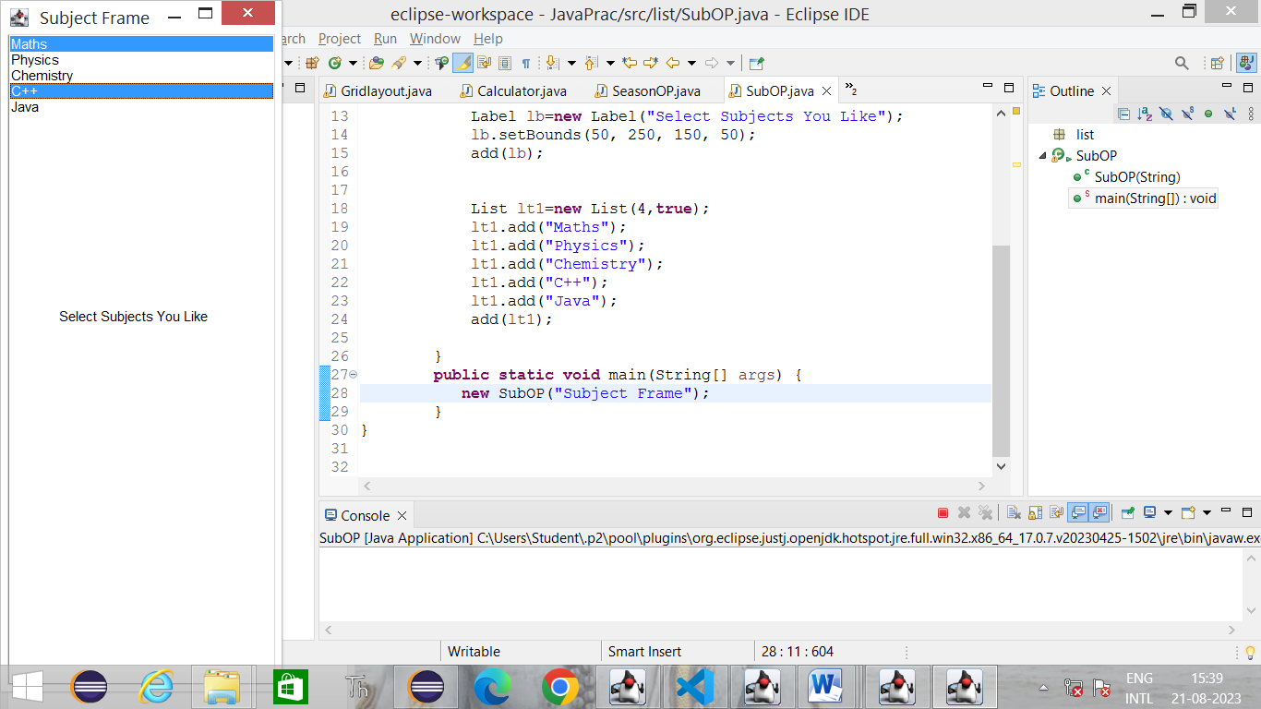

**Code-**

import java.awt.*;

public class SubOP extends Frame

{

public SubOP(String s)

{

super(s);

setVisible(true);

setSize(400,600);

Label lb=new Label("Select Subjects You Like");

lb.setBounds(50, 250, 150, 50);

add(lb);

List lt1=new List(4,true);

lt1.add("Maths");

lt1.add("Physics");

lt1.add("Chemistry");

lt1.add("C++");

lt1.add("Java");

add(lt1);

}

public static void main(String[] args) {

new SubOP("Subject Frame");

}

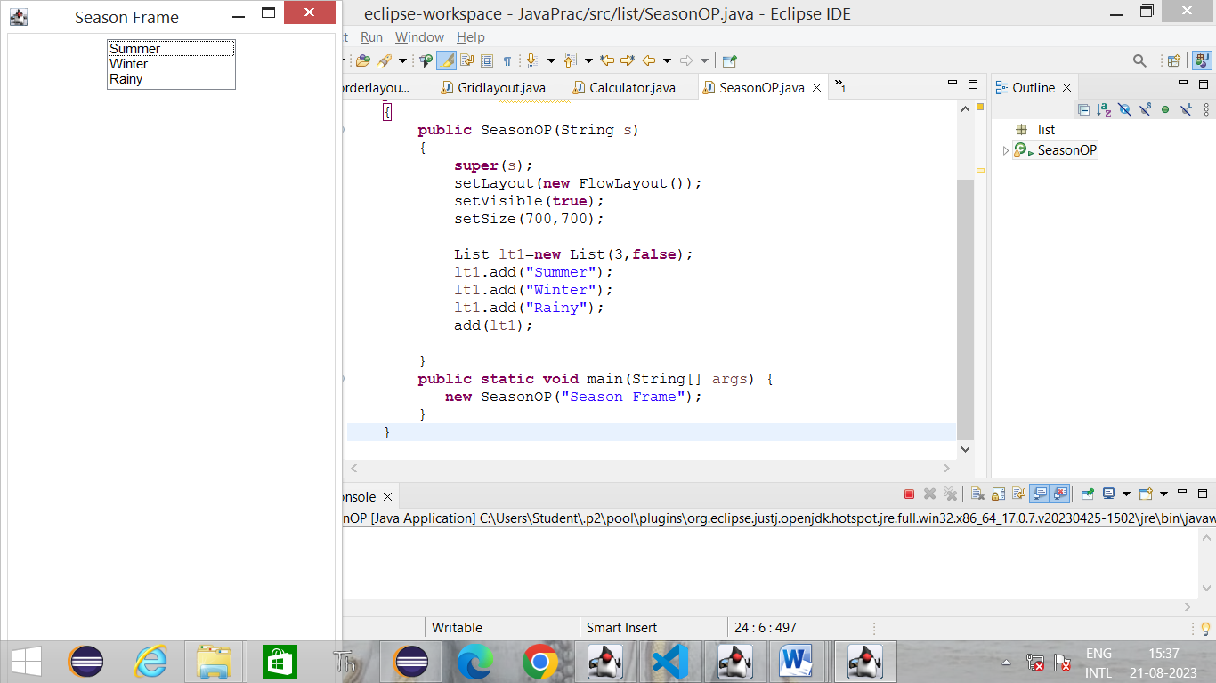}

**Output-**